

**Transport Accessibility in Metropolitan Melbourne**



# **Table of Contents**

# **Introduction**

# **Methodology**

# **Results**

# **Discussion**

# **References**

# **Appendix**

## **1. Introduction:**

This report aims to analyze transport accessibility in the Melbourne Metropolitan area, focusing on the distribution and density of public transport routes and stops. The analysis leverages spatial data to understand how well Melbourne’s transport system serves its population. Key questions addressed in this report include:

* How are public transport routes distributed across Melbourne?
* Which areas have high or low transport stop densities, and what does that imply for accessibility?

# **2. Methodology:**

# **Dataset Overview**

The analysis used the General Transit Feed Specification (GTFS) data and Australian Boundary datasets, which were restored into the PostgreSQL/PostGIS database for spatial processing. The GTFS data includes detailed transport routes, stops, trips, and schedule information, while the boundary data provides the geographic context, specifically focusing on Melbourne Metropolitan area boundaries.

# **Data Restoration:**

The data restoration process involved using **PostgreSQL** with the **PostGIS** extension for spatial data handling and the **Docker terminal** for executing commands. The tools employed included **unzip** for extracting compressed files and **ogr2ogr** for loading shape files into the PostgreSQL database. The restoration process started by unzipping the necessary files using the Docker terminal, including stop_times.txt, shapes.txt, and the shape files MB_2021_AUST_GDA2020.shp and MB_2021_AUST_GDA2020.dbf. Once the files were extracted, I used the head command to inspect the structure of each dataset. For example, inspecting agency.txt revealed key columns such as agency_id, agency_name, agency_url, agency_timezone, and agency_lang, which helped in defining the schema for the corresponding table.

Next, I proceeded to create tables for all 11 files, ensuring that any existing tables with the same names were dropped to prevent conflicts. This schema definition process was repeated for all files, including calendar.txt, routes.txt, trips.txt, stop_times.txt, and the boundary datasets such as LGA_2021 and SAL_2021. Spatial data from the shape files was then imported into the PostgreSQL database using the ogr2ogr command to handle geographic information.

After the tables were defined, I used the COPY command to load the data from each file into its corresponding table. This included files such as stop_times.txt, calendar.txt, routes.txt, shapes.txt, LGA_2021_AUST.csv, and SAL_2021_AUST.csv.

Finally, to ensure the data was correctly restored, I executed a verification query to check the row counts for each table. This step confirmed that all tables were properly populated, ensuring a successful data restoration process.

Note: For a detailed view of the output, please refer to Appendix.

# **Data Preprocessing:**

1. **Filtering Mesh Blocks for Melbourne Metropolitan Area**: The mb_2021 table contains mesh blocks for the whole of Australia. To limit the scope to Melbourne Metropolitan, mesh blocks where gcc_name21 = 'Greater Melbourne' were filtered and stored in a new table mb2021_mel.
2. **Creating a Single Polygon for Melbourne Metropolitan Boundary**: To facilitate spatial queries, a boundary polygon for the Melbourne Metropolitan area was created by aggregating all the mesh blocks from mb2021_mel.
3. **Adding a Geometry Column to the Stops Table**: Since the stops table did not have a geometry column, a new geom column was added to store the spatial data derived from latitude and longitude values.
4. **Populating the Geometry Column**: The latitude (stop_lat) and longitude (stop_lon) values were converted into spatial points using PostGIS, and the spatial reference system GDA2020 (SRID: 7844) was applied.
5. **Finding Stops Within Melbourne Metropolitan Boundary**: A spatial join was performed to identify which stops fall within the Melbourne Metropolitan boundary using the ST_Within() function.
6. **Counting Transport Stops by Vehicle Type**: The final step involved counting the number of stops by transport mode (tram, train, bus) within the Melbourne boundary. The route_type from the routes table was used to categorize each stop.

# **Data Analysis and Visualization:**

In this section, we analyse transport accessibility in the Melbourne Metropolitan area by focusing on **stop density** and **transport route distribution** for trams, trains, and buses. The analysis is conducted using spatial queries in PostgreSQL with the PostGIS extension and visualized through QGIS. This allows us to gain insights into which regions are well-served by public transport and identify potential gaps in the network.

**Area of Exploration: Stop Density and Route Distribution**

The analysis focused on two key aspects:

1. **Stop Density**: Calculating the number of stops per square kilometre for different regions in Melbourne. This measures how accessible public transport is within each region.
2. **Transport Route Distribution**: Mapping tram, train, and bus routes to examine how well these modes cover the Melbourne Metropolitan area.

## Analysis and SQL Queries

**Public Transport Route:**

The analysis conducted focused on visualizing the **public transport routes** in Melbourne by plotting **tram**, **train**, and **bus** routes. This was achieved by creating spatial data points for transport routes and generating lines representing the routes within the Melbourne boundary using **PostgreSQL with PostGIS**.

To effectively represent the data, we used **map-based visualizations** to plot the geographical spread of transport routes, allowing for clear identification of areas with high connectivity and transport gaps. These visualizations were chosen because they provide a clear, intuitive way to understand spatial relationships and route distribution, which are crucial for analysing transport accessibility.

This allows us to visualize the spread of each transport mode and identify regions with high connectivity or underserved areas.

**Stop Density Analysis:**

The **Stop Density Analysis** involved calculating the density of public transport stops within each region. By aggregating the total number of stops and dividing by the area of each region, we derived the number of stops per square kilometre. This analysis provides insights into how well-served each region is in terms of transport accessibility.

**Visualisation**: A heatmap was used to represent stop density, where regions with higher density of stops appear more prominently. This visualization was effective in identifying areas with high or low transport service coverage.

**Visualization Approach**

The analysis results are visualized using QGIS to create:

1. **Stop Density Map**: Showing the density of transport stops across different regions of Melbourne.
2. **Transport Route Map**: Mapping tram, train, and bus routes to highlight areas with overlapping services and gaps in coverage.

**Software and Tools**

* **PostgreSQL with PostGIS**: For executing spatial queries and managing geographic data.
* **QGIS**: For creating visualizations that display stop density and route distribution.

These visualizations provide a clear representation of Melbourne’s public transport network, revealing key patterns in accessibility and potential areas for improvement.

## **3. Results**

## 1. Public Transport Route Visualization:

The first map visualizes the public transport routes (trams, trains, and buses) across Melbourne. These routes are essential to understanding how accessible public transport is across different parts of the city. The visualization makes use of multiple SQL queries to extract and aggregate geometric data of transport routes, providing a clear picture of how different transport modes are distributed geographically.

## Key Insights:

* **Central Melbourne as a High-Connectivity Zone:**
  + The map highlights that central Melbourne is covered by a dense network of transport routes. This area benefits from overlapping transport modes (tram, train, and bus routes), particularly in the CBD and inner suburbs. This overlapping coverage suggests that residents and commuters in this region have excellent access to public transport, enabling them to travel quickly and efficiently within and beyond the metropolitan area.
  + These densely connected areas also provide opportunities for multi-modal travel, where passengers can switch between different transport modes easily, contributing to high connectivity
* **Extensive Tram Network:**
  + Trams are highly concentrated in central Melbourne, radiating outward but diminishing significantly as you move away from the inner city. This suggests that trams are a vital mode of transport within Melbourne's inner suburbs, particularly for shorter commutes. The extensive tram network around the CBD ensures that most residents have access to this mode within walking distance.
  + Beyond this central hub, tram routes become sparse, indicating that outer suburbs rely less on trams for transport and more on buses and trains.
* **Train Routes Connecting to the Outer Suburbs:**
  + Train routes in the map extend further into the outer suburbs, illustrating their role in connecting commuters living farther from the CBD to the city center. The train network serves as a backbone for long-distance commutes, particularly in areas like the northeastern and southeastern suburbs.
  + However, the visualization also reveals that train stations become less frequent and more dispersed in outer areas, meaning that residents in these regions may need to travel greater distances to reach a station compared to those living in central areas.
* **Bus Routes Covering Large Areas:**
  + The map shows that bus routes are more evenly distributed across the entire metropolitan region, covering both inner and outer suburbs. Buses provide an essential service for residents who do not have access to trams or trains, especially in the more sparsely populated outer suburbs.
  + The extensive bus coverage complements the less dense tram and train networks, ensuring that even the peripheral regions of Melbourne have some level of public

transport access. However, bus routes alone might not provide the same efficiency as other transport modes for long-distance travel.

## Critical Observations:

* **Reduced Accessibility in the Outer Suburbs:**
  + While central Melbourne enjoys overlapping transport services, the map reveals gaps in the transport network as you move further out into the outer suburbs. These areas often lack trams and are primarily served by buses and occasional train routes. The absence of multi-modal transport options in these regions may lead to lower transport connectivity and longer commutes.
  + This raises questions about transport equity, as residents in outer areas may face challenges accessing frequent and reliable public transport. Improving transport routes in these areas could be key to ensuring equitable accessibility across the entire metropolitan region.
* **Opportunities for Hub Development:**
  + Several regions with overlapping transport modes (e.g., train and tram routes) can be identified as potential interchange hubs. These areas are highly connected and may be well-positioned for future transport investments. Targeting these hubs with improvements or expansions could enhance Melbourne’s overall connectivity by making it easier for commuters to switch between transport modes.

## **2. Stop Density Analysis:**

The second map focuses on the density of public transport stops across various regions of Melbourne, which is a direct measure of transport accessibility. The stop density is calculated by dividing the number of stops by the area of each region, providing insight into how well-served each region is by public transport.

**Key Insights:**

* **High-Density Areas:**
  + The regions around central Melbourne (e.g., South Yarra, Prahran, and the CBD) have the highest stop densities, meaning that there are more stops per square kilometre in these areas than anywhere else in the city. This high density of stops suggests excellent public transport coverage. Residents in these areas are more likely to have easy access to public transport within walking distance, improving convenience and reducing the need for car travel.
  + These areas are typically highly urbanized and densely populated, and the concentration of stops reflects both the demand for frequent public transport and the availability of multiple transport options (tram, train, and bus services).
* **Low-Density Areas:**
  + Conversely, regions on the fringes of the metropolitan area (e.g., outer suburbs like Lilydale or Cranbourne) have much lower stop densities. These regions are less urbanized and more sparsely populated, which likely contributes to the lower density of public transport stops.
  + Lower stop density means that residents in these areas may need to travel greater distances to reach a public transport stop, potentially discouraging public transport use and increasing reliance on private vehicles.
* **Correlation with Population Density:**
  + Stop density correlates with population density in many cases. Central areas with high population densities, such as St Kilda or Fitzroy, also have high stop densities, indicating strong accessibility. On the other hand, rural and suburban areas tend to have fewer stops relative to their area, reflecting their lower population densities and reduced demand for public transport.

## Critical Observations:

* **Transport Equity Issues:**
  + The stark contrast in stop density between central and outer regions underscores potential equity issues. Residents of more suburban or rural regions may face limited access to frequent public transport, which could impact commuting times and mobility options, particularly for those without access to private vehicles.
  + Addressing these disparities in stop density could be an important consideration for future transport policy planning, especially as Melbourne’s population continues to grow and expand outward.
* **Potential for Improvement:**
  + Areas with low stop density represent potential opportunities for infrastructure improvement. Expanding bus services in suburban regions or introducing new routes in underserved areas could help to bridge the gap between central and outer suburbs, improving transport access for all residents.
  + Additionally, the development of transport hubs in strategic outer regions could increase transport efficiency and promote the use of public transport over private vehicles.

## Conclusion:

This analysis of Melbourne's transport network offers valuable insights into transport accessibility across the city. The first visualization highlights how transport routes are distributed across different modes, revealing high connectivity in the central metropolitan area and the need for better coverage in the outer suburbs. The second visualization emphasizes the disparities in stop density, providing a clear indicator of which regions are well-served by public transport and which areas may need further attention.

By considering both route coverage and stop density, this analysis contributes to a deeper understanding of how Melbourne's residents interact with the public transport network and identifies areas for potential improvement in equitable transport access.

## **4. Discussion**

## Key Findings:

* **Central Melbourne** enjoys extensive transport accessibility, benefiting from multiple overlapping routes (tram, bus, train), allowing for efficient travel.
* **Outer Suburbs** experience lower accessibility, primarily served by buses and trains, with fewer stops and routes available compared to the inner city.

## Implications:

The findings suggest that while Melbourne has a robust public transport network, there are clear gaps in the outer suburbs. Improving transport routes and increasing the number of stops in these regions could enhance overall transport accessibility, reducing reliance on private vehicles.

## Limitations:

* This analysis only considered the spatial distribution of stops, without accounting for service frequency or capacity.
* Data on real-time transport availability or future developments was not considered, which could affect conclusions on accessibility.

## **5. References**

* Australian Bureau of Statistics. (2021–2026). *Australian Statistical Geography Standard (ASGS) Edition 3: Digital Boundary Files*. Retrieved from <https://www.abs.gov.au/statistics/standards/australian-statistical-geography-standard-asgs-edition-3/jul2021-jun2026/access-and-downloads/digital-boundary-files>
* Australian Bureau of Statistics. (2021–2026). *Australian Statistical Geography Standard (ASGS) Edition 3: Overview*. Retrieved from <https://www.abs.gov.au/statistics/standards/australian-statistical-geography-standard-asgs-edition-3/jul2021-jun2026#overview>
* Australian Bureau of Statistics. (2021–2026). *Australian Statistical Geography Standard (ASGS) Edition 3: Allocation Files*. Retrieved from <https://www.abs.gov.au/statistics/standards/australian-statistical-geography-standard-asgs-edition-3/jul2021-jun2026/access-and-downloads/allocation-files>
* Google Developers. (n.d.). *General Transit Feed Specification (GTFS)*. Retrieved from <https://developers.google.com/transit/gtfs>
* Transit Feeds. (n.d.). *PTV Greater Melbourne (GTFS) – Transit Feeds*. Retrieved from <https://transitfeeds.com/p/ptv/497>

## **6. Appendix:**

## Link to access the plots:

Please use the following [link](https://drive.google.com/drive/folders/14KIsjmY56cEKQdFJYGIluKfwMeffvi4l?usp=sharing) to download the QGIS files and dataset, which will offer a detailed and clearer view of the plots.

## SQL scripts used for creating, processing, and querying data.

The following commands were used to extract the files:

**Unzipping stop_times.txt**:



**Unzipping shapes.txt**:



**Unzipping shape file MB_2021_AUST_GDA2020.shp**:



**Unzipping shape file MB_2021_AUST_GDA2020.dbf**:



**Inspecting the Data:**

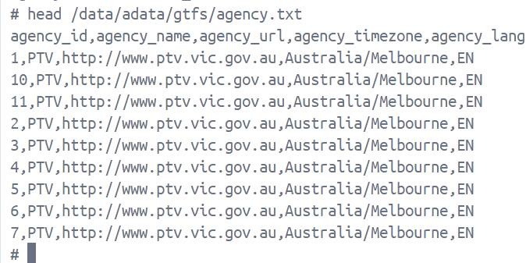

**Table Creation:**

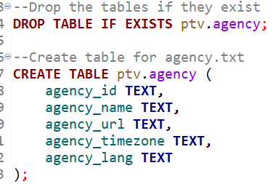

**Shape File Import:**



**Data Loading:**



**Filtering Mesh Blocks for Melbourne Metropolitan Area:**

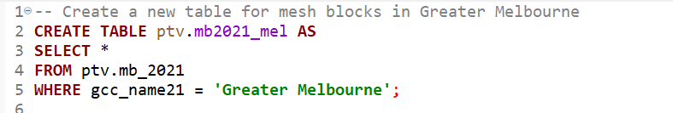

Output:

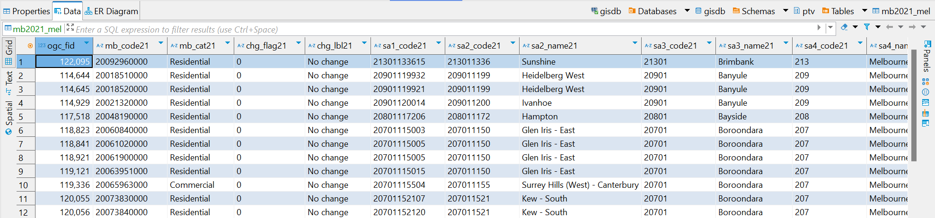

**Creating a Single Polygon for Melbourne Metropolitan Boundary:**



Output:



**Adding a Geometry Column to the Stops Table:**



**Populating the Geometry Column:**



Output:

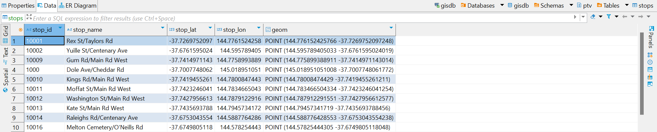

**Finding Stops Within Melbourne Metropolitan Boundary:**

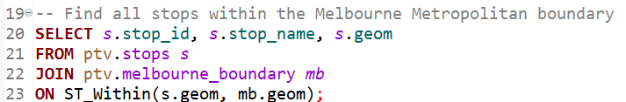

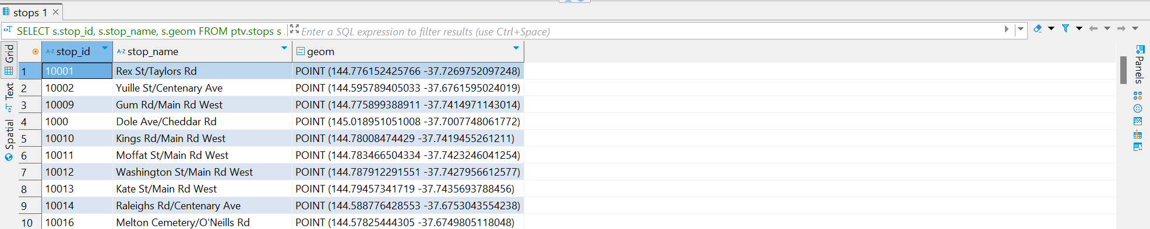

**Counting Transport Stops by Vehicle Type:**

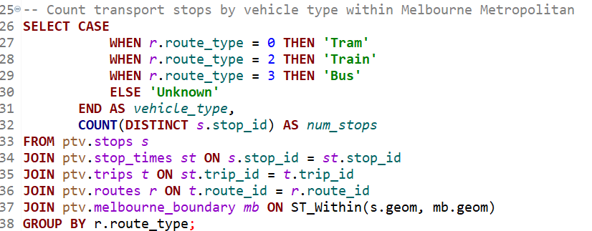

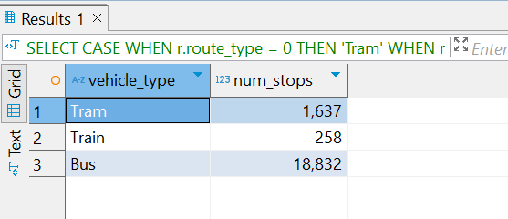

**Screenshots of restored tables and row counts.**

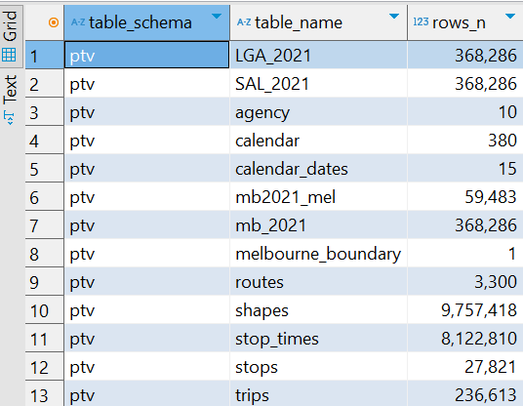

**Public Transport Route Query:**

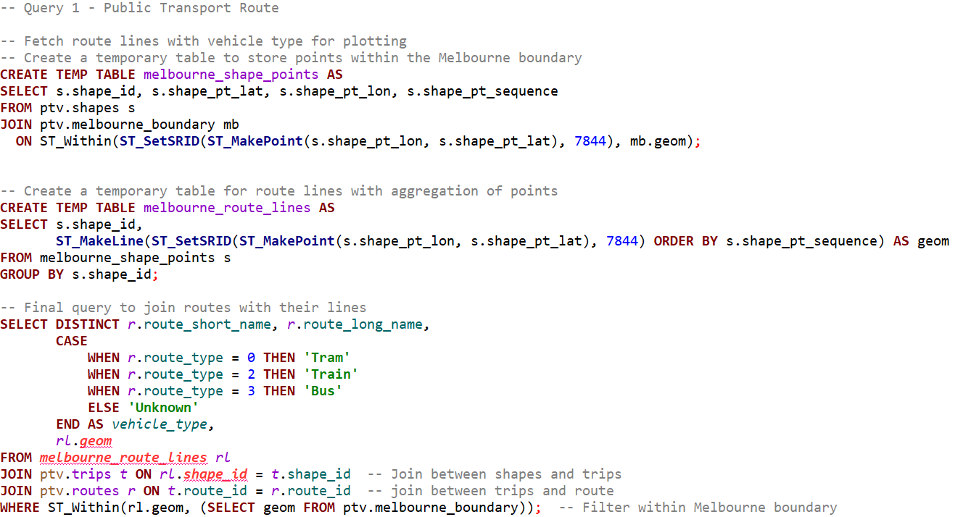

**Stop Density Analysis Query:**

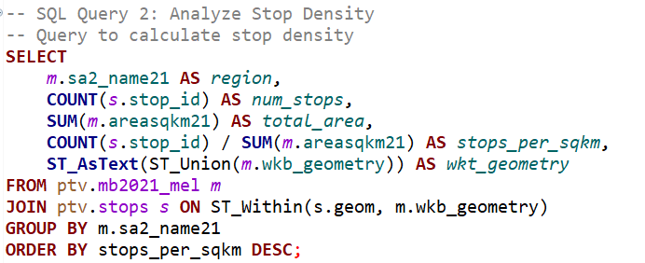

**Visualizations (map-based figures) for public transport routes and stop density.**

**1. Public Transport Route Visualization**

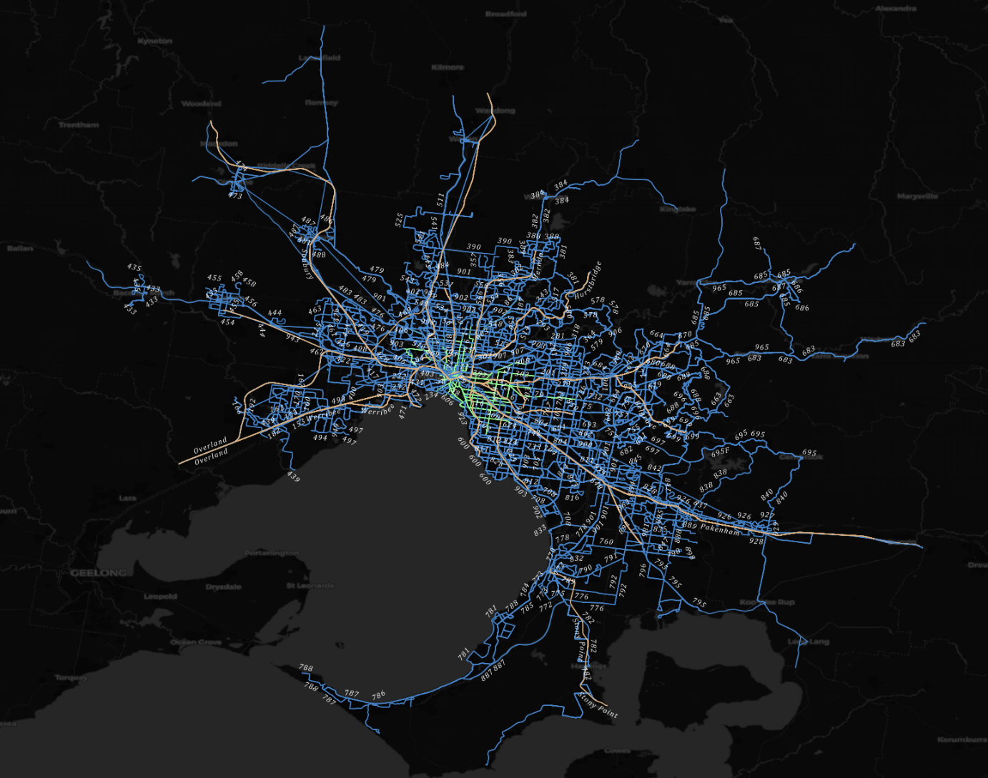

**2.Stop Density Visualization:**

